**DOCUMENTATION**

**NodeJS + MongoDB - Simple API for Authentication, Registration and User Management**

**Running the NodeJS + MongoDB API Locally**

1.Install NodeJS and NPM from https://nodejs.org/en/download/.

2.Install MongoDB Community Server from https://www.mongodb.com/download-center.

3.Run MongoDB, instructions are available on the install page for each OS at <https://docs.mongodb.com/manual/administration/install-community/>

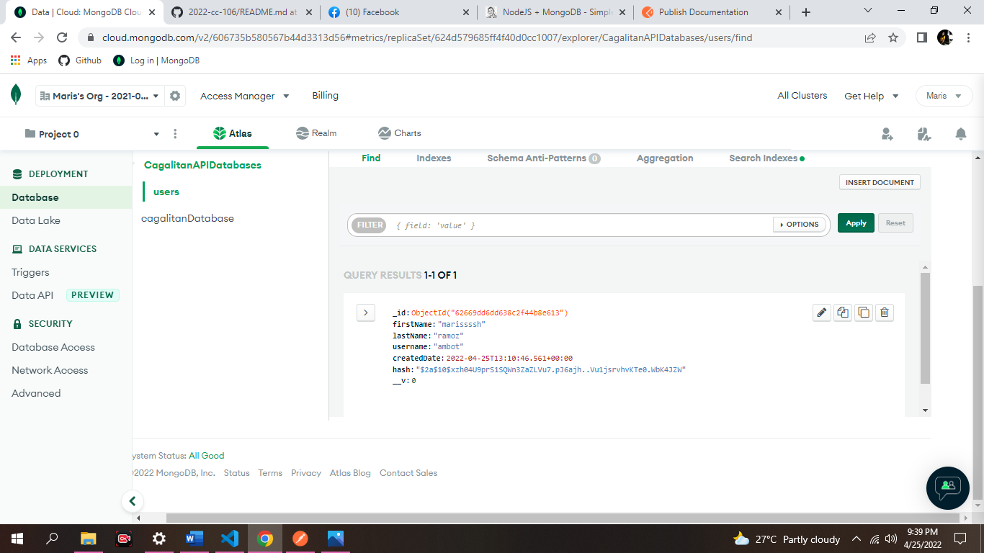

4.Download or clone the project source code from https://github.com/cornflourblue/node-mongo-registration-login-api 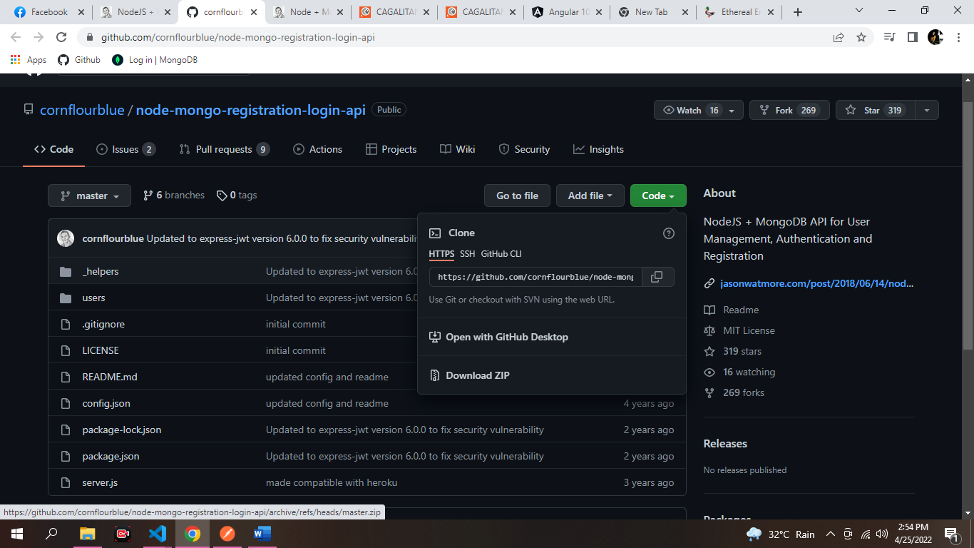

CLICK THE CODE AND DOWNLOAD ZIP AFTER DOWNLOADING RIGHT CLICK YOU CAN SEE. SHOW THE FOLDER .CLICK IT.

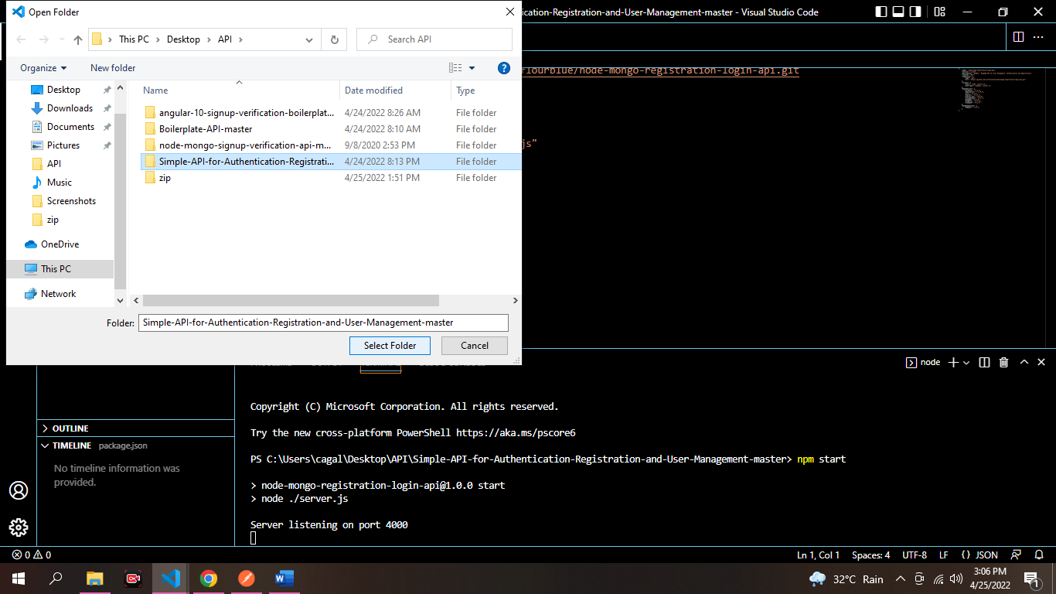

5.NEXT, ENTER THE VISUAL CODE CLICK SIMPLE API FOLDER

THEN SELECT FOLDER.

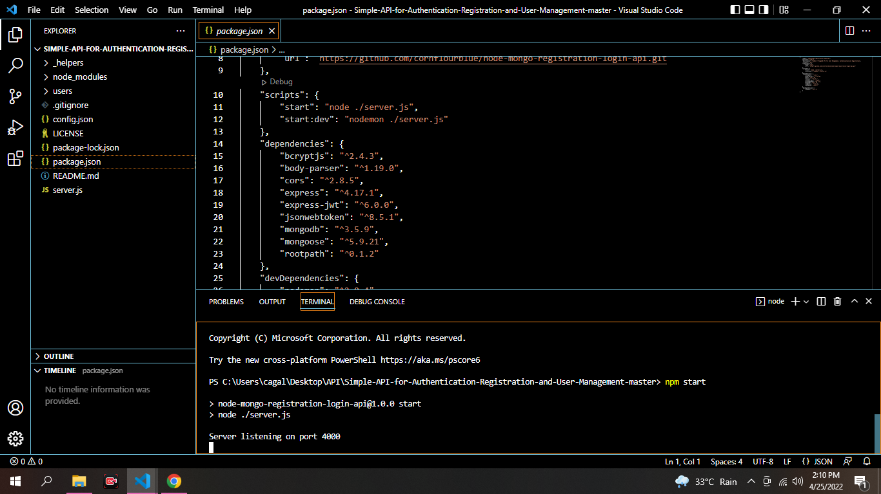

5. npm packages by running npm install from the command line in the project root folder (where the package.json is located).

6.Start the api by running npm start from the command line in the project root folder, you should see the message Server listening on port 4000.

**Testing the Node Auth API with Postman**

Postman is a great tool for testing APIs, you can download it at <https://www.getpostman.com/>.

1.POST REGISTRATION

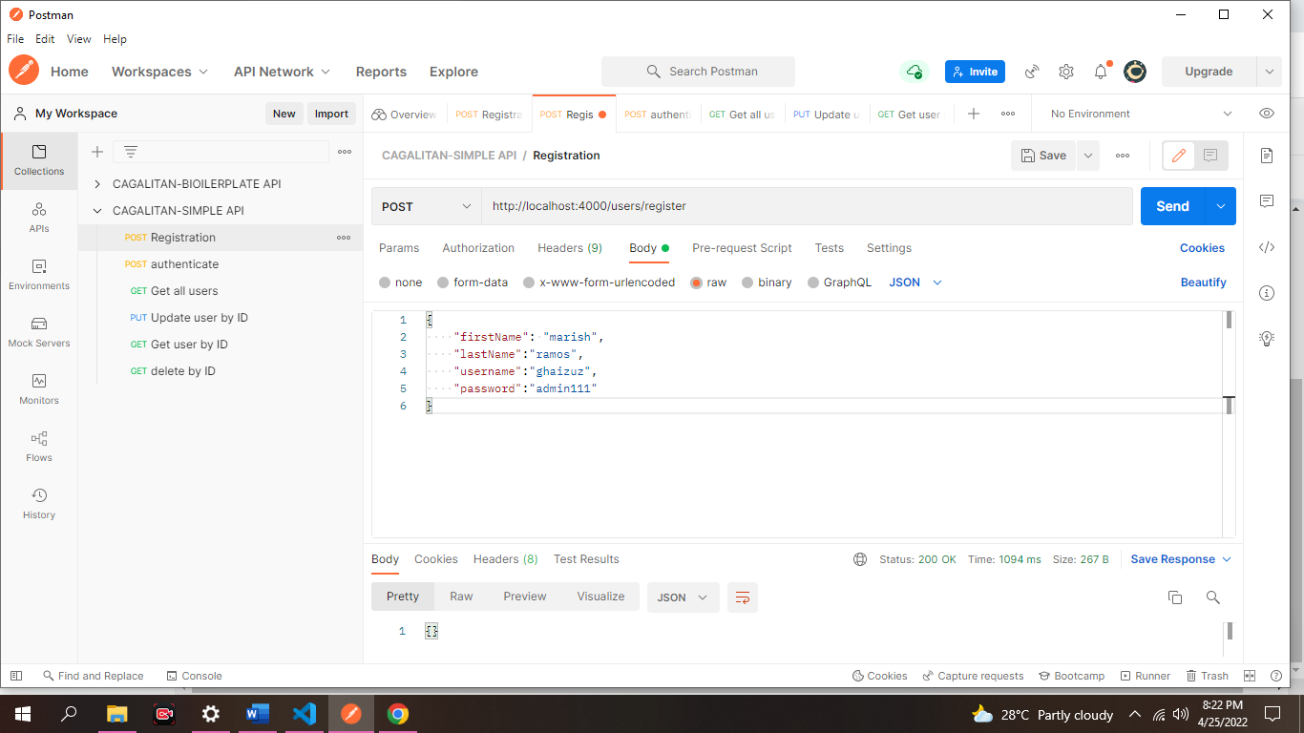

2. POST AUTHENTICATE

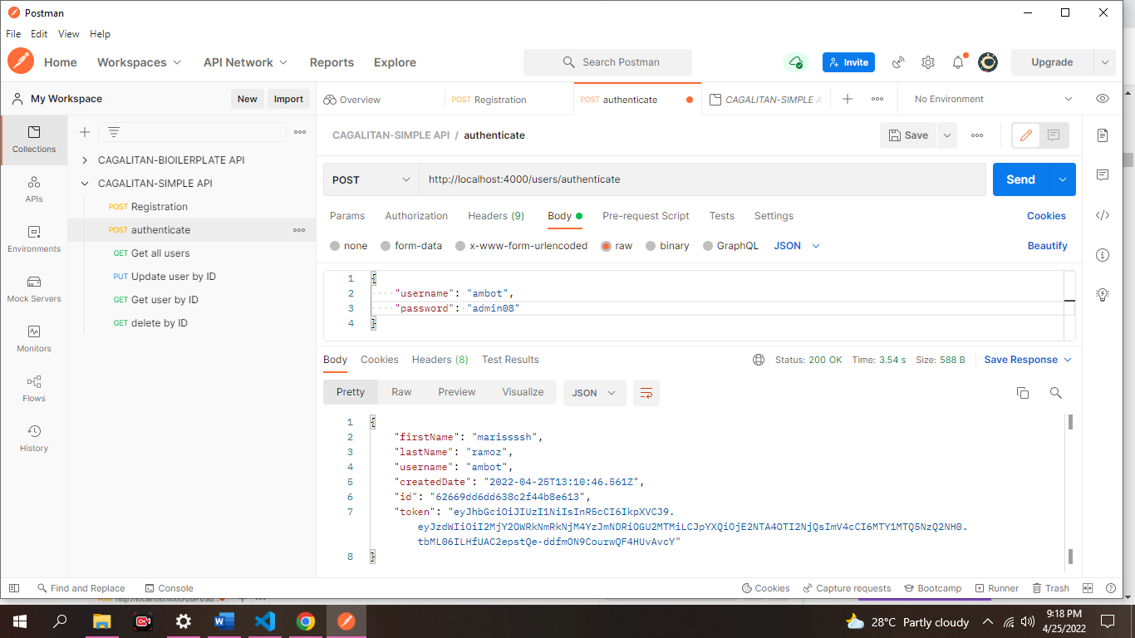

3. GET ALL USERS

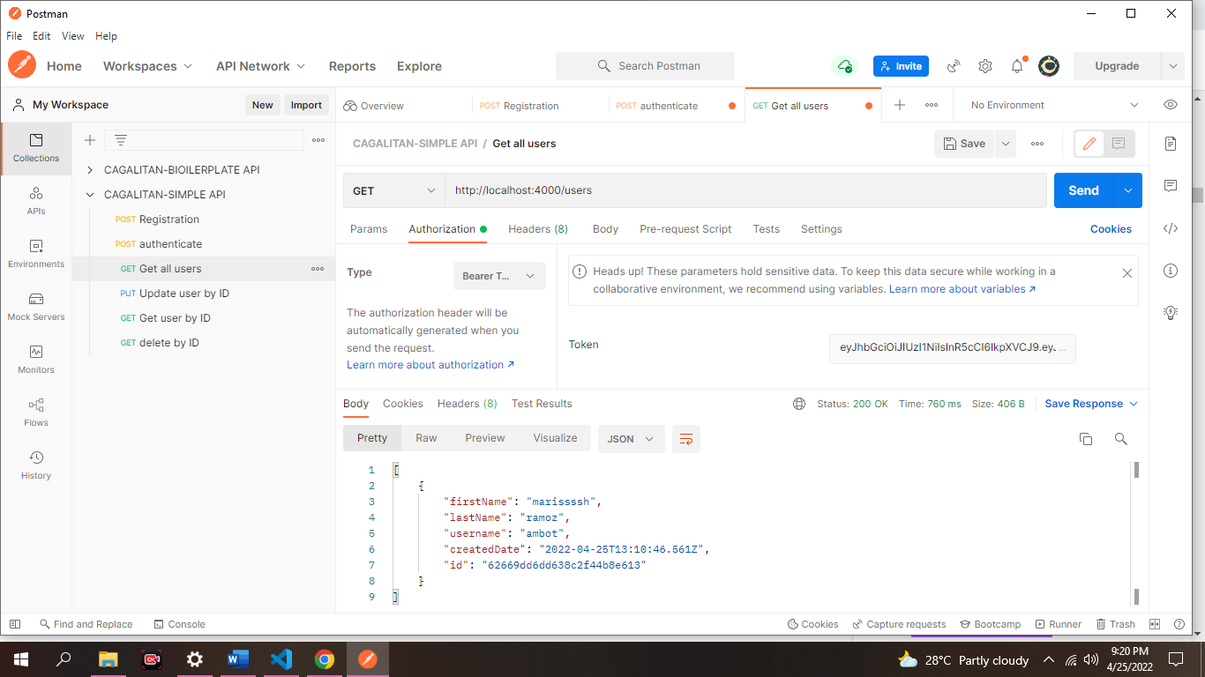

4.PUT-UPDATE USER BY ID

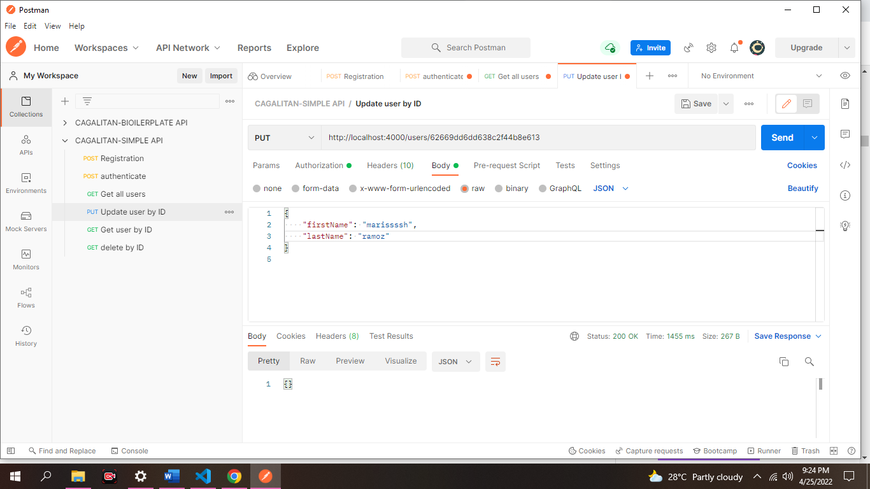

Node + Mongo - Boilerplate API with Email Sign Up, Verification, Authentication & Forgot Password

Running the Node + Mongo Boilerplate API Locally

Install NodeJS and NPM from https://nodejs.org/en/download/.

Install MongoDB Community Server from https://www.mongodb.com/download-center/community.

Run MongoDB, instructions are available on the install page for each OS at https://docs.mongodb.com/manual/administration/install-community/

Download or clone the project source code from <https://github.com/cornflourblue/node-mongo-signup-verification-api>

Running an Angular 10 App with the Node Boilerplate API

Download or clone the Angular 10 tutorial code from https://github.com/cornflourblue/angular-10-signup-verification-boilerplate

